Terraform Challenge-02
- Create VPC
- Create Internet gateway
- Create Custom Route Table
- Create Subnet
- Associate subnet with Route Table
- Create Security Group to allow port 22.80,443
- Create a network interface with an ip in the subnet that was created in step 4
- Assign an elastic IP to the network interface created in step 7
- Create Ubuntu server and install/enable apache2
We’ll create this architecture:
Internet
|
Internet Gateway
|
Custom Route Table
|
Public Subnet
|
Network Interface
|
Elastic IP
|
Ubuntu EC2
|
Apache2
Port 80/443
What we will create
Step | AWS Resource | Terraform Resource
1 | VPC | aws_vpc
2 | Internet Gateway | aws_internet_gateway
3 | Route Table | aws_route_table
4 | Subnet | aws_subnet
5 | Route Table Association | aws_route_table_association
6 | Security Group | aws_security_group
7 | Network Interface | aws_network_interface
8 | Elastic IP | aws_eip
9 | Ubuntu EC2 + Apache | aws_instance

Step 1 — Create Project Folder
Since you're using Windows + VS Code, create:
Terraform-Final-Task
Open it in VS Code.
Inside the folder, create these files:
Terraform-Final-Task/
│
├── provider.tf
├── variables.tf
├── main.tf
├── outputs.tf
└── terraform.tfvars
We'll keep it simple for the final task.
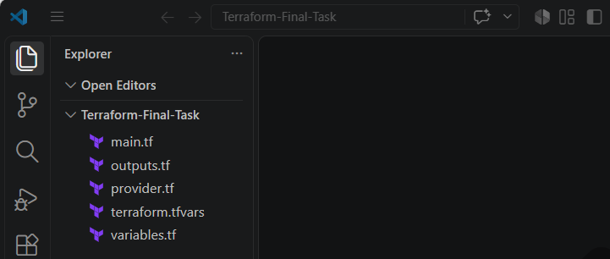

Step 2 — Configure AWS Provider
Create:
provider.tf
terraform {
required_providers {
aws = {
source = "hashicorp/aws"
version = "~> 6.0"
}
}

required_version = ">= 1.6.0"
}

provider "aws" {
region = var.aws_region
}

Step 3 — Create Variables
Create:
variables.tf
variable "aws_region" {
description = "AWS Region"
type = string
}

variable "vpc_cidr" {
description = "CIDR block for VPC"
type = string
}

variable "subnet_cidr" {
description = "CIDR block for public subnet"
type = string
}

variable "availability_zone" {
description = "Availability Zone"
type = string
}

variable "instance_type" {
description = "EC2 instance type"
type = string
}

variable "key_name" {
description = "Existing EC2 Key Pair name"
type = string
}

Step 4 — Add Variable Values
Create:
terraform.tfvars
For example, if you're using Mumbai:
aws_region = "ap-south-1"
vpc_cidr = "10.0.0.0/16"
subnet_cidr = "10.0.1.0/24"
availability_zone = "ap-south-1a"
instance_type = "t3.micro"
key_name = "your-key-name"
Change:
your-key-name
to the actual EC2 Key Pair name you already have in AWS.
For example:
key_name = "docker-practice-key"

Step 5 — Create VPC
Now open:
main.tf
Add:
resource "aws_vpc" "main" {
cidr_block = var.vpc_cidr
enable_dns_support = true
enable_dns_hostnames = true

tags = {
Name = "terraform-final-vpc"
}
}
What happens?
Terraform creates:
VPC
CIDR = 10.0.0.0/16

Step 6 — Create Internet Gateway
Add below the VPC:
resource "aws_internet_gateway" "igw" {
vpc_id = aws_vpc.main.id

tags = {
Name = "terraform-final-igw"
}
}
Notice:
vpc_id = aws_vpc.main.id
Terraform automatically understands:
Internet Gateway depends on the VPC.

Step 7 — Create Custom Route Table
Add:
resource "aws_route_table" "public" {
vpc_id = aws_vpc.main.id

route {
cidr_block = "0.0.0.0/0"
gateway_id = aws_internet_gateway.igw.id
}

tags = {
Name = "terraform-final-public-rt"
}
}
The important part is:
cidr_block = "0.0.0.0/0"
This means:
Traffic destined for anywhere on the internet.
And:
gateway_id = aws_internet_gateway.igw.id
means:
Send that traffic through the Internet Gateway.

Step 8 — Create Subnet
Add:
resource "aws_subnet" "public" {
vpc_id = aws_vpc.main.id
cidr_block = var.subnet_cidr
availability_zone = var.availability_zone
map_public_ip_on_launch = false

tags = {
Name = "terraform-final-public-subnet"
}
}
We are intentionally setting:
map_public_ip_on_launch = false
because our requirement is to create a Network Interface and then attach an Elastic IP.

Step 9 — Associate Subnet with Route Table
Add:
resource "aws_route_table_association" "public" {
subnet_id = aws_subnet.public.id
route_table_id = aws_route_table.public.id
}
Now the architecture becomes:
VPC
|
+-- Internet Gateway
|
+-- Route Table
|
+-- Public Subnet
|
+-- Route Table Association

Step 10 — Create Security Group
Requirement:
Allow ports 22, 80 and 443.
Add:
resource "aws_security_group" "web_sg" {
name = "terraform-final-web-sg"
description = "Allow SSH HTTP and HTTPS"
vpc_id = aws_vpc.main.id

ingress {
description = "SSH"
from_port = 22
to_port = 22
protocol = "tcp"
cidr_blocks = ["0.0.0.0/0"]
}

ingress {
description = "HTTP"
from_port = 80
to_port = 80
protocol = "tcp"
cidr_blocks = ["0.0.0.0/0"]
}

ingress {
description = "HTTPS"
from_port = 443
to_port = 443
protocol = "tcp"
cidr_blocks = ["0.0.0.0/0"]
}

egress {
description = "Allow all outbound traffic"
from_port = 0
to_port = 0
protocol = "-1"
cidr_blocks = ["0.0.0.0/0"]
}

tags = {
Name = "terraform-final-web-sg"
}
}
For a real production server, SSH should generally be restricted to your own IP rather than:
0.0.0.0/0
But for this lab/final task, this is straightforward.

Step 11 — Create Network Interface
This is one of the important requirements.
Add:
resource "aws_network_interface" "web_eni" {
subnet_id = aws_subnet.public.id

private_ips = ["10.0.1.10"]

security_groups = [
aws_security_group.web_sg.id
]

tags = {
Name = "terraform-final-eni"
}
}
We are telling AWS:
Create an ENI inside my subnet and give it private IP 10.0.1.10.
Architecture:
Public Subnet
|
+---- ENI
|
+---- Private IP: 10.0.1.10

Step 12 — Create Elastic IP
Add:
resource "aws_eip" "web_eip" {
domain = "vpc"

tags = {
Name = "terraform-final-eip"
}
}
Now associate it with our ENI:
resource "aws_eip_association" "web_eip_assoc" {
allocation_id = aws_eip.web_eip.id
network_interface_id = aws_network_interface.web_eni.id
}
So:
Elastic IP
|
v
Network Interface
|
v
Private IP 10.0.1.10

Step 13 — Find Ubuntu AMI
For the EC2 instance, we need an Ubuntu AMI.
Instead of hardcoding an AMI ID, we can let Terraform find the latest Ubuntu image.
Add:
data "aws_ami" "ubuntu" {
most_recent = true

owners = ["099720109477"]

filter {
name = "name"
values = ["ubuntu/images/hvm-ssd-gp3/ubuntu-noble-24.04-amd64-server-*"]
}

filter {
name = "virtualization-type"
values = ["hvm"]
}

filter {
name = "root-device-type"
values = ["ebs"]
}
}
The owner ID:
099720109477
is Canonical's AWS account ID for Ubuntu images.

Step 14 — Create Ubuntu EC2
Now create the server.
Add:
resource "aws_instance" "web" {
ami = data.aws_ami.ubuntu.id
instance_type = var.instance_type
key_name = var.key_name

network_interface {
network_interface_id = aws_network_interface.web_eni.id
device_index = 0
}

user_data = <<-EOF
#!/bin/bash

apt-get update -y

apt-get install -y apache2

systemctl enable apache2

systemctl start apache2

echo "<h1>Terraform Final Task - Apache Server</h1>" > /var/www/html/index.html
EOF

tags = {
Name = "terraform-final-apache-server"
}
}
This is the final major component.

Step 15 — Understand user_data
This part:
user_data = <<-EOF
runs when the EC2 instance starts.
We're executing:
apt-get update -y
Then:
apt-get install -y apache2
Then:
systemctl enable apache2
This makes Apache start automatically after reboot.
Then:
systemctl start apache2
starts Apache immediately.
Finally:
echo "<h1>Terraform Final Task - Apache Server</h1>" > /var/www/html/index.html
creates our web page.
Therefore, after deployment:
http://ELASTIC-IP
should display:
Terraform Final Task - Apache Server

Step 16 — Outputs
Create:
outputs.tf
output "vpc_id" {
description = "VPC ID"
value = aws_vpc.main.id
}

output "subnet_id" {
description = "Public Subnet ID"
value = aws_subnet.public.id
}

output "security_group_id" {
description = "Security Group ID"
value = aws_security_group.web_sg.id
}

output "network_interface_id" {
description = "Network Interface ID"
value = aws_network_interface.web_eni.id
}

output "private_ip" {
description = "Private IP"
value = aws_network_interface.web_eni.private_ip
}

output "elastic_ip" {
description = "Elastic IP"
value = aws_eip.web_eip.public_ip
}

output "instance_id" {
description = "EC2 Instance ID"
value = aws_instance.web.id
}

output "apache_url" {
description = "Apache Web URL"
value = "http://${aws_eip.web_eip.public_ip}"
}

Step 17 — Your Final Folder
You should now have:
Terraform-Final-Task/
│
├── provider.tf
├── variables.tf
├── terraform.tfvars
├── main.tf
└── outputs.tf
And main.tf contains:
1. VPC
2. Internet Gateway
3. Route Table
4. Subnet
5. Route Table Association
6. Security Group
7. Network Interface
8. Elastic IP
9. Ubuntu EC2
10. Apache installation

Step 18 — Run Terraform
Open the VS Code terminal.
First check:
terraform version
Then:
terraform init
You should see something similar to:
Terraform has been successfully initialized!
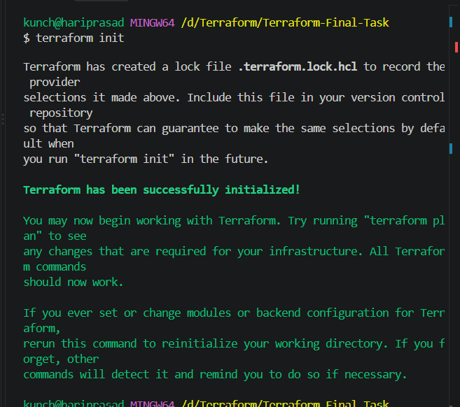

Step 19 — Format the Code
Run:
terraform fmt
Then:
terraform validate
Expected:
Success! The configuration is valid.
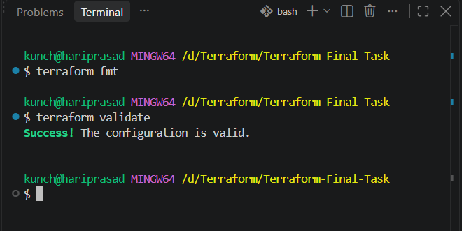

Step 20 — Terraform Plan
Now:
terraform plan
Terraform should show resources that it plans to create.
You should expect approximately:
aws_vpc
aws_internet_gateway
aws_route_table
aws_subnet
aws_route_table_association
aws_security_group
aws_network_interface
aws_eip
aws_eip_association
aws_instance
Plus the Ubuntu AMI data lookup.
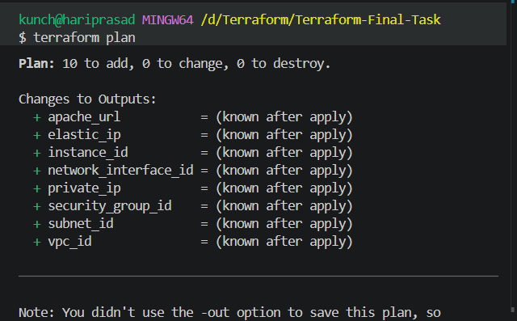

Step 21 — Apply
Now:
terraform apply
Terraform will ask:
Do you want to perform these actions?
Enter:
yes
Wait for the deployment to finish.
At the end, you should see something like:
Apply complete! Resources: 10 added, 0 changed, 0 destroyed.

Outputs:

apache_url = "http://x.x.x.x"
elastic_ip = "x.x.x.x"
instance_id = "i-xxxxxxxx"
network_interface_id = "eni-xxxxxxxx"
private_ip = "10.0.1.10"
subnet_id = "subnet-xxxxxxxx"
vpc_id = "vpc-xxxxxxxx"
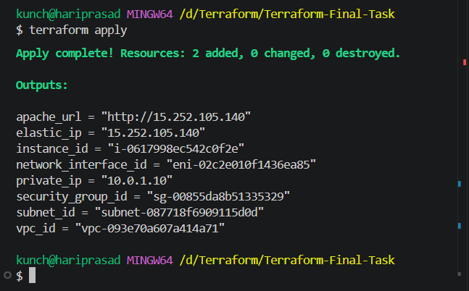

Step 22 — Test Apache
Copy the output:
apache_url
For example:
http://13.xx.xx.xx
Open it in your browser.
You should see:
Terraform Final Task - Apache Server
🎉 That confirms the complete infrastructure is working.
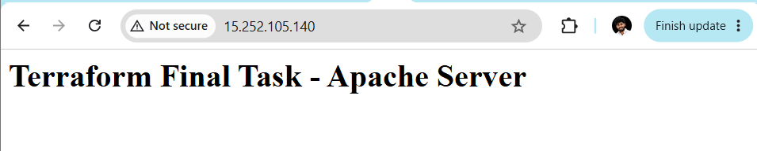

Step 23 — Verify from AWS Console
Go to AWS Console → VPC.
You should see:
VPC
└── terraform-final-vpc
│
├── Internet Gateway
│
├── Public Subnet
│
├── Route Table
│
├── Security Group
│
└── Network Interface
│
└── 10.0.1.10
│
└── Elastic IP
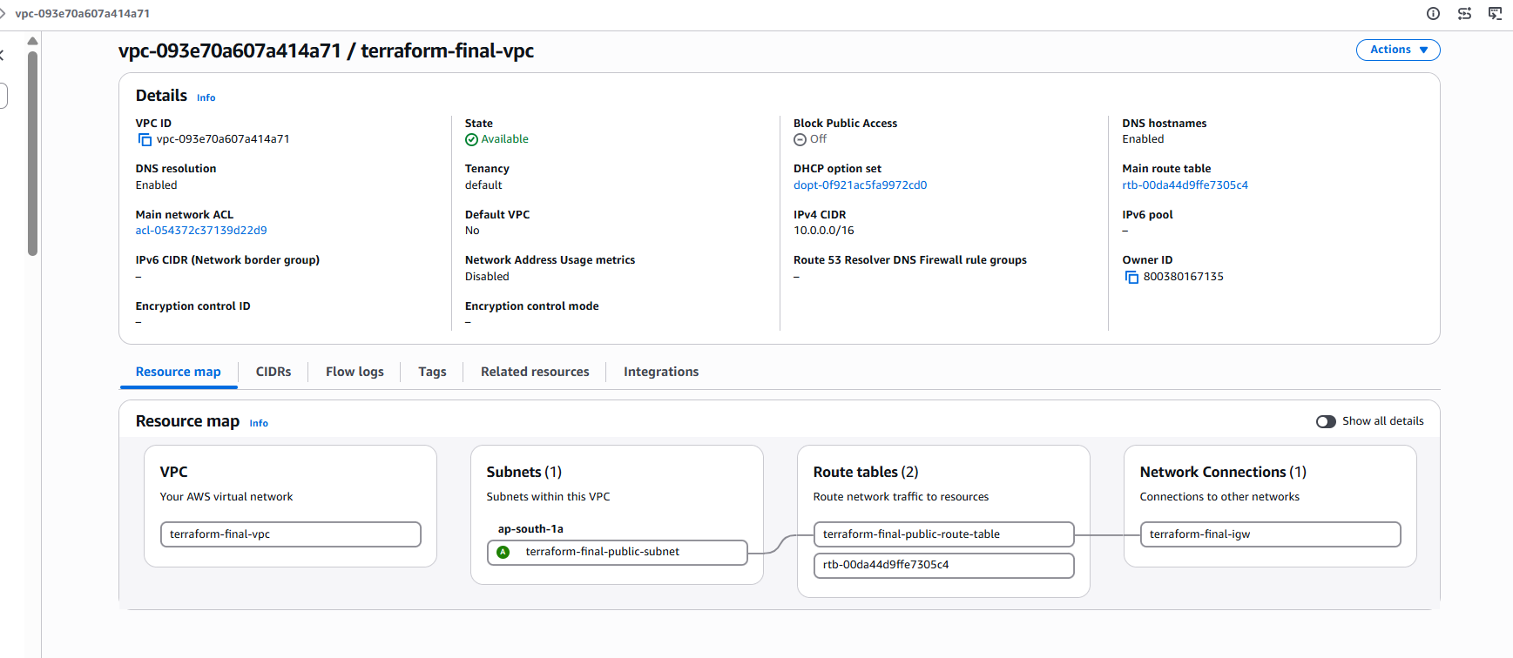
Then EC2:
EC2
└── terraform-final-apache-server
│
└── Ubuntu
│
└── Apache2
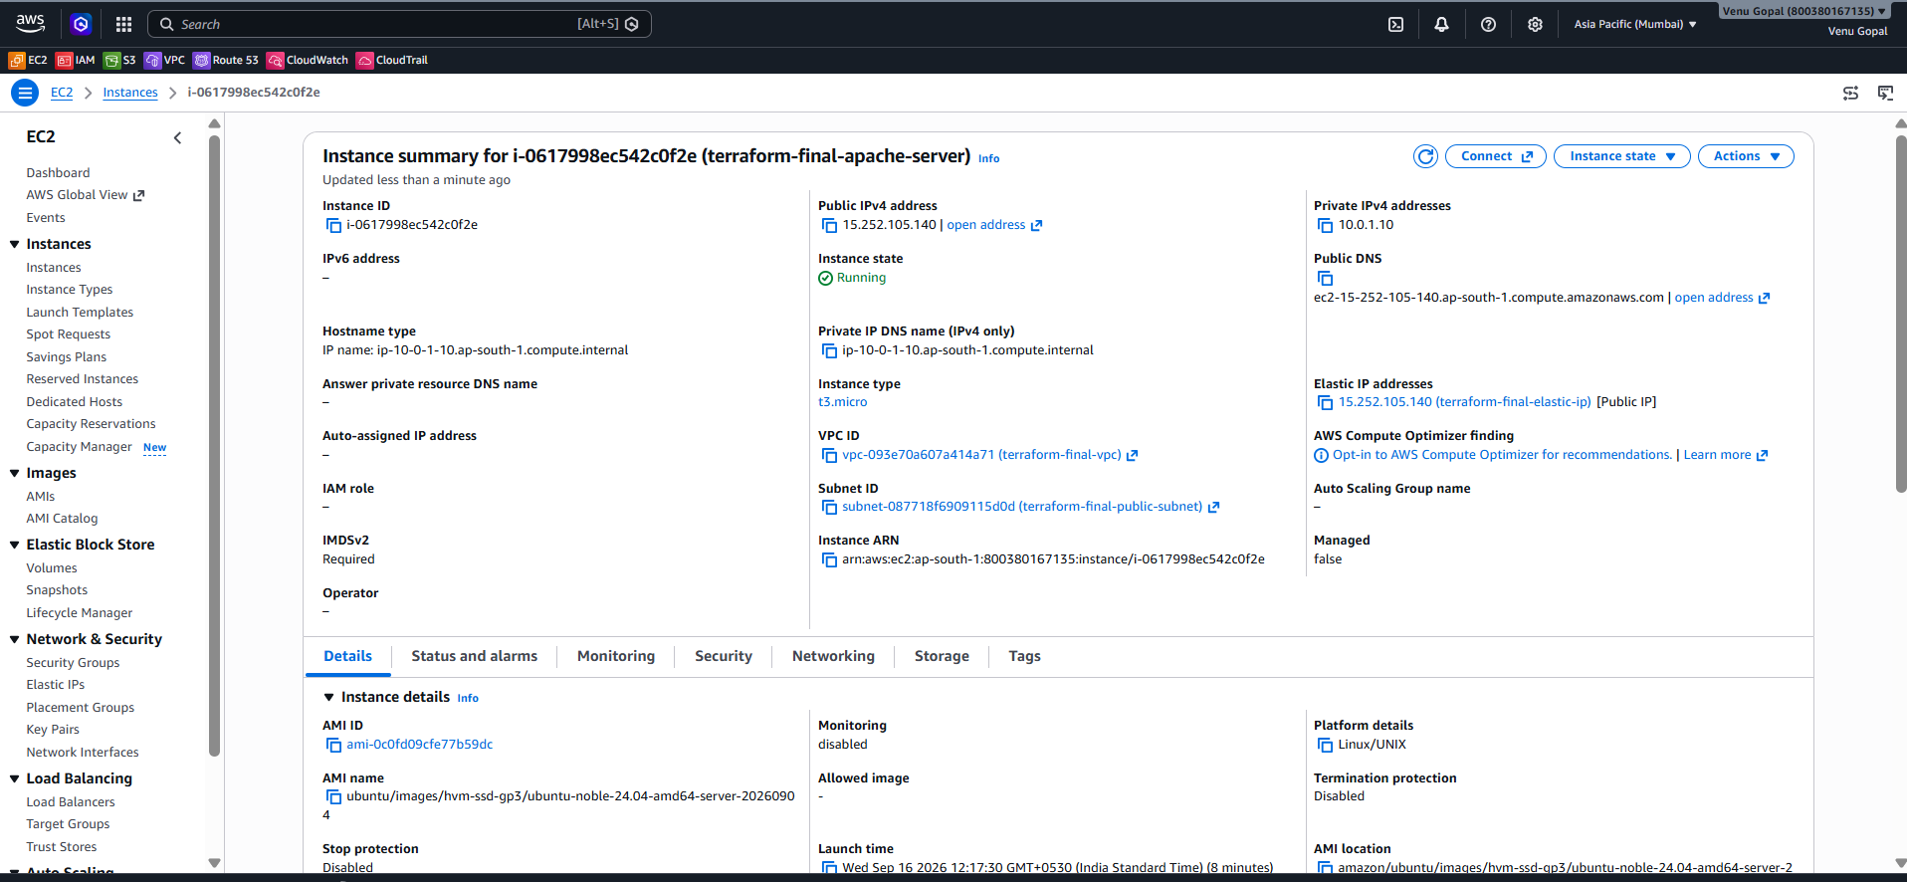

Step 24 — Verify Apache Through SSH
You can SSH into the server using its Elastic IP:
ssh -i your-key.pem ubuntu@15.252.105.140
Then:
sudo systemctl status apache2
You should see:
Active: active (running)
You can also verify:
curl localhost
You should get:
<h1>Terraform Final Task - Apache Server</h1>
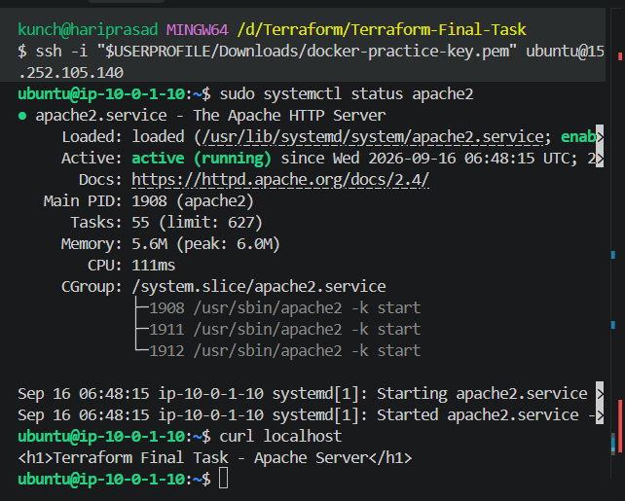

Step 25 — Verify the Network Interface
Inside the server:
ip addr
You should find the private IP:
10.0.1.10
And from your computer:
http://<Elastic-IP>
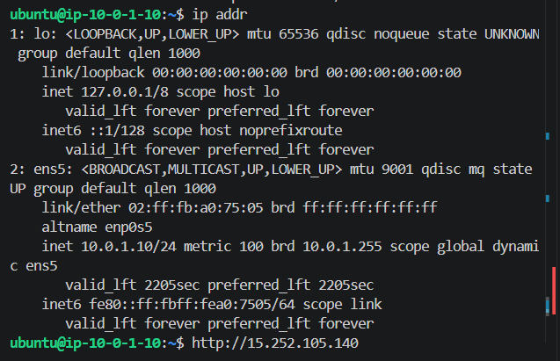
works because:
Internet
↓
Elastic IP
↓
Network Interface
↓
Security Group : Port 80
↓
Ubuntu EC2
↓
Apache
